**Assignment 4.4 -**

1. Use the package RcmdrPlugin.IPSUR.

data(RcmdrTestDrive)

and perform the below operations:

a. Calculate the average salary by gender and smoking status.

data1<-RcmdrPlugin.IPSUR::RcmdrTestDrive

# To find the average salary by gender

With(data1, by(salary, gender, mean))

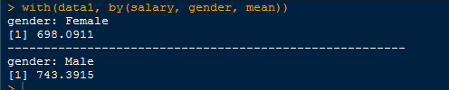

# to find the smoking status by gender

table(data1$gender, data1$smoking)



OR

With(data1, table(smoking, gender)) or with(data1, table(gender,smoking))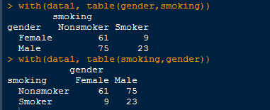

b. Which gender has the highest mean salary?

Male gender has highest mean salary.

c. Report the highest mean salary.

Mean(data1$salary)

https://lh3.googleusercontent.com/Wt1wmQoUix4psyRgE4g-rlLvJ-HrqDn0XD2v1ATx2CjA0OLyFmMUgbpXjasCRpHf3miQoxGHhDiCrX7kfLyQU3tP4Kbl1020UmQoqSDdy4DdEzBjFwmWFh3knhvneCm9yePlkoY8jJw-KUc4qg

d. Compare the spreads for the genders by calculating the standard deviation of salary by gender.

With(data1, by(salary,  gender, sd)

